SF.SmokeTestScripts_TC_SF_OBRequiredFieldsOnSalesStage_Instance1_12-Apr-2017_02-21-37_PM_Invoke_Application.png



SF.SmokeTestScripts_TC_SF_OBRequiredFieldsOnSalesStage_Instance1_12-Apr-2017_02-21-44_PM_Login.png

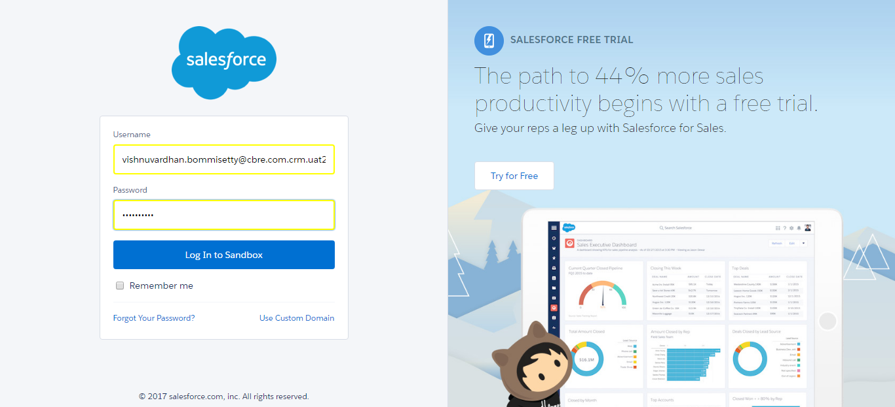

SF.SmokeTestScripts_TC_SF_OBRequiredFieldsOnSalesStage_Instance1_12-Apr-2017_02-21-53_PM_Verify_Login.png

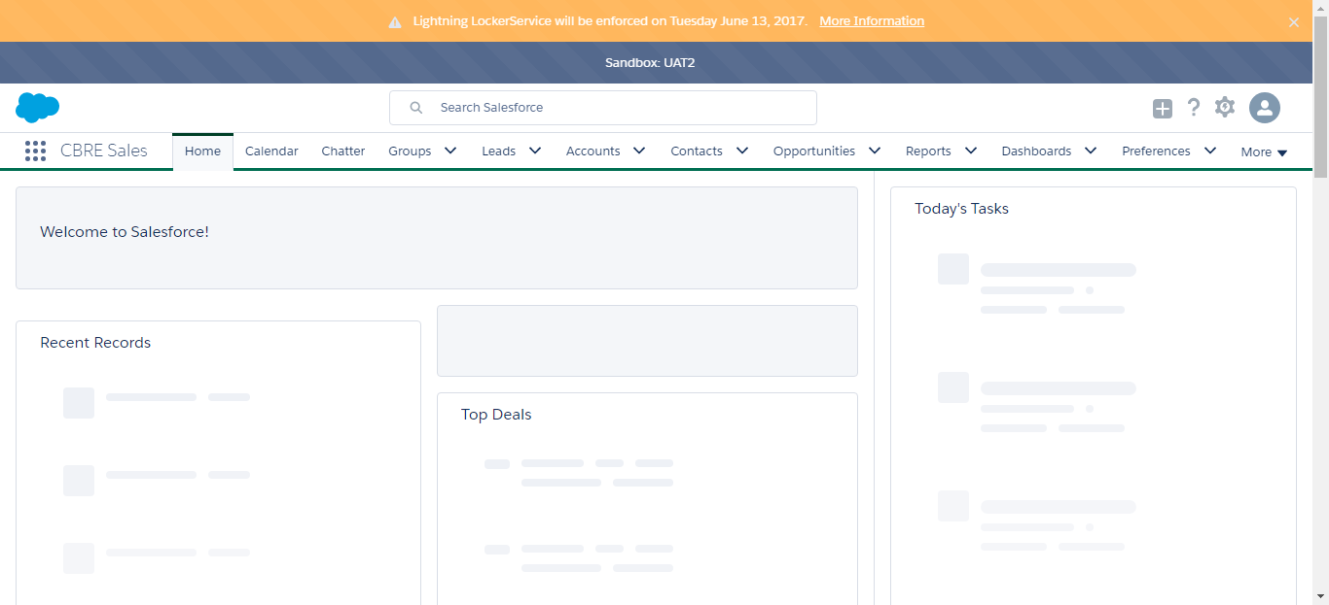

SF.SmokeTestScripts_TC_SF_OBRequiredFieldsOnSalesStage_Instance1_12-Apr-2017_02-21-54_PM_Verify_Fetch_Record.png

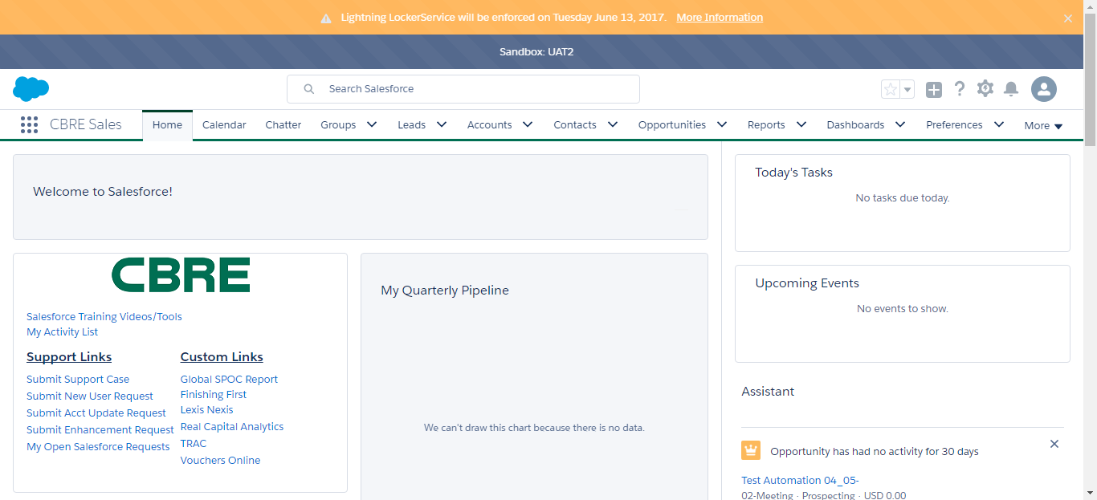

SF.SmokeTestScripts_TC_SF_OBRequiredFieldsOnSalesStage_Instance1_12-Apr-2017_02-22-26_PM_Verify_Opportunity_Required



SF.SmokeTestScripts_TC_SF_OBRequiredFieldsOnSalesStage_Instance1_12-Apr-2017_02-23-47_PM_Verify_Fetch_Record.png



SF.SmokeTestScripts_TC_SF_OBRequiredFieldsOnSalesStage_Instance1_12-Apr-2017_02-23-47_PM_Verify_Opportunity_Required



SF.SmokeTestScripts_TC_SF_OBRequiredFieldsOnSalesStage_Instance1_12-Apr-2017_02-23-59_PM_Verify_Add_Opportunity_Page



SF.SmokeTestScripts_TC_SF_OBRequiredFieldsOnSalesStage_Instance1_12-Apr-2017_02-24-24_PM_Verify_Add_Opportunity_Page

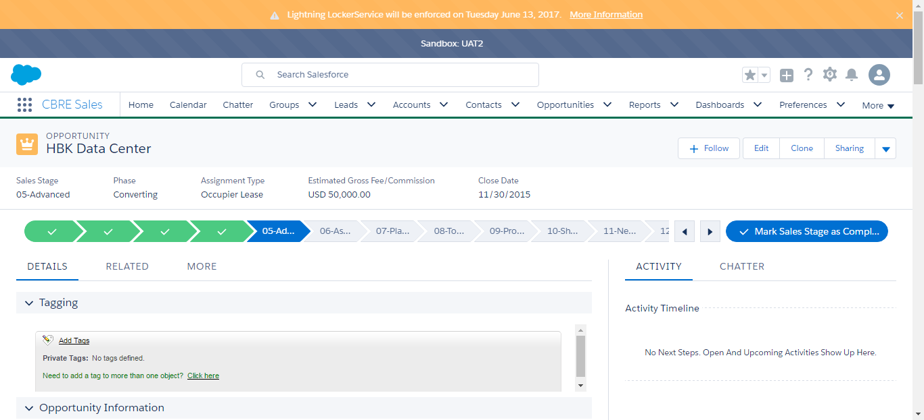

SF.SmokeTestScripts_TC_SF_OBRequiredFieldsOnSalesStage_Instance1_12-Apr-2017_02-28-29_PM_Error.png

